Marketing Campaign Insight Analysis

This project includes the following files:

1. **Marketing_cam_Dash.pbix**: This is a Power BI file, containing dashboards or visualizations related to the marketing campaign data.
2. **README.md**: A markdown file containing documentation or instructions about the project, detailing its purpose, usage, and structure.
3. **main. ipynb**: A Jupyter notebook, which includes code for data analysis, cleaning, visualization, and other steps related to the marketing campaign.
4. **marketing_campaign.csv**: A CSV file, containing raw data about the marketing campaign, such as customer details, campaign metrics, and outcomes.

This project is all about analysing how well marketing campaigns are performing to see how effective they are and how engaged customers are. By digging into the data, the goal is to understand how customers are responding to the campaigns and use those insights to make smarter, more informed recommendations.

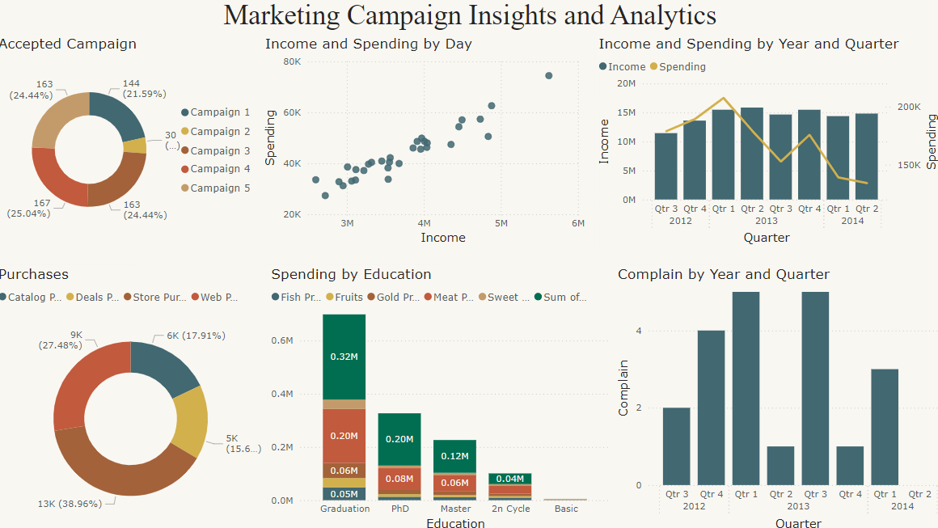

Loan Approval Prediction Analysis

This project includes the following files:

1. **Loan_approval.pbix**: This is a Power BI file, containing dashboards or visualizations related to the loan approval predictions from the insight data.
2. **README.md**: A markdown file containing documentation or instructions about the project, detailing its purpose, usage, and structure.
3. **approval. ipynb**: A Jupyter notebook, which includes code for the regression algorithm first to enhance the dataset then the code for data analysis and visualization.
4. **Loan_approval.csv**: A CSV file, containing raw data about the loan approval, such as loan amount, age, marital status, bank id etc.

The main aim of this project is to dig into and showcase data around loan approval predictions. By creating this report, we’re shedding light on the critical factors that impact whether a loan gets approved or not. We also explore the different demographics of applicants and uncover trends in how loan applications have been handled. This helps us understand the bigger picture behind who gets approved for loans and why.

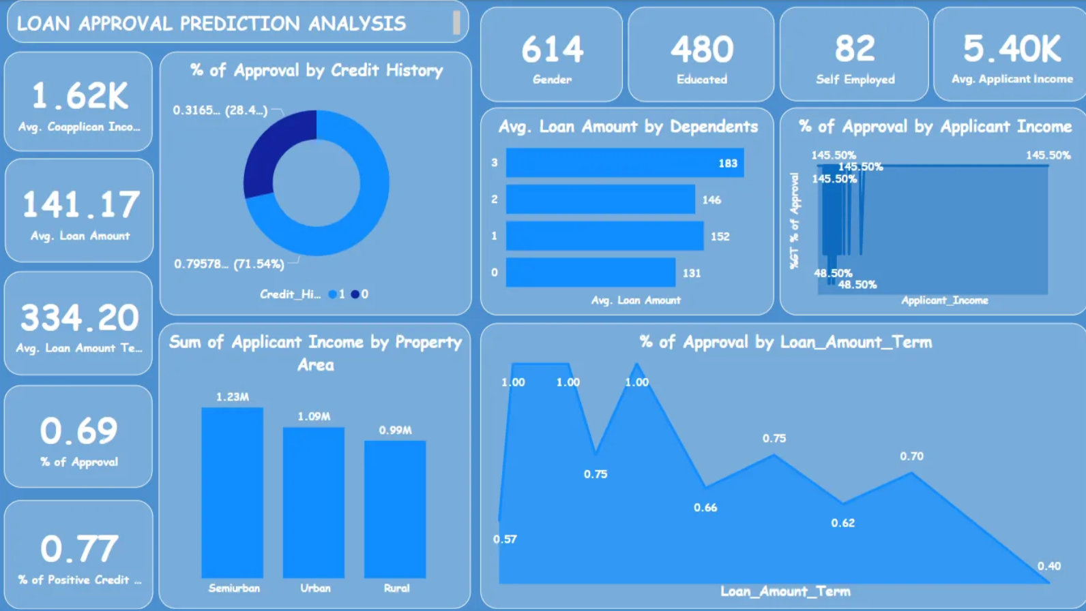

Credit Card Fraud Detection Analysis

This project includes:

1. **Credit_card.ipynb** : It contains an implementation of credit card fraud detection using Random Forest and Decision Trees. Credit card fraud is a significant issue in the financial industry, and machine learning algorithms offer effective solutions for detecting fraudulent transactions.
2. **Credit_fault .pbix**: This is a Power BI file, containing dashboards or visualizations related to the credit card faults from the insight data.

The main aim of this project is to dig into and showcase data around loan approval predictions. By creating this report, we’re shedding light on the critical factors that impact whether a loan gets approved or not. We also explore the different demographics of applicants and uncover trends in how loan applications have been handled. This helps us understand the bigger picture behind who gets approved for loans and why.

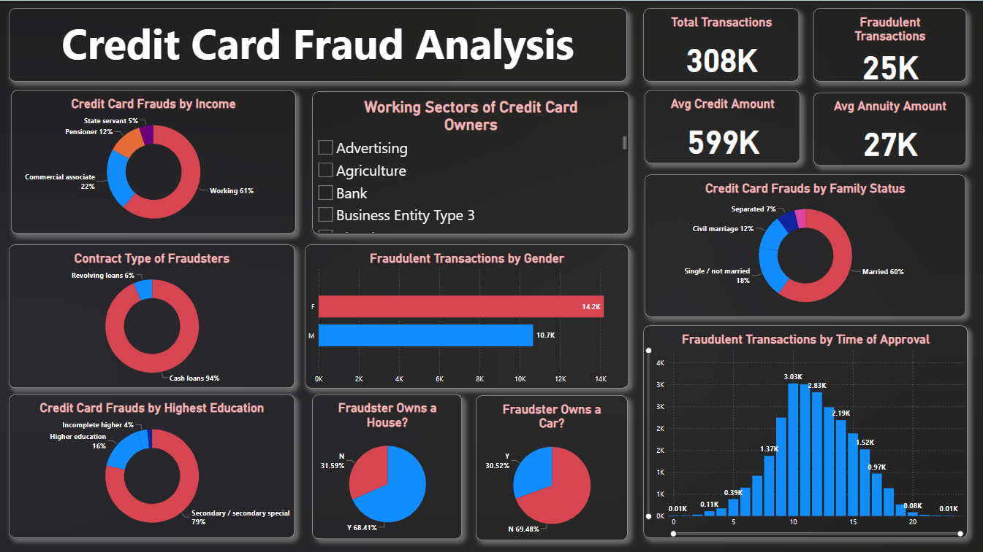

Risk Analysis of Google Stock

This project includes the following files:

* **Risk_Analysis. ipynb** This notebook conducts a risk analysis of Google stock (GOOG) by using historical data thus providing insights into the stock's potential future price movements and associated risks.

The main aim of this project is to analyse the risk associated with investing in Google stock (GOOG). This is achieved by using statistical methods, particularly Monte Carlo simulations, to forecast potential future price movements and calculate the Value-at-Risk (Var). The objective is to quantify the potential loss an investor might face under normal market conditions, thereby assessing the stability and risk level of investing in Google stock.

The risk analysis of Google stock reveals that it is a stable investment with a relatively low risk of significant loss. The Monte Carlo simulations, combined with the VaR analysis, provide a clear picture of the potential outcomes of investing in Google stock. Investors can be confident that the risk of extreme loss is minimal, making Google a potentially secure addition to an investment portfolio.

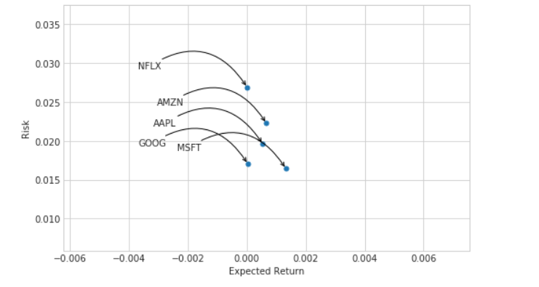

From this plot we can see that Microsoft has the highest expected return and the lowest risk -- a sign that it is the best stock to buy at the moment. With its overhaul of its cloud computing sectors and high-profile acquisitions, Microsoft stock is a clear winner here. Netflix's performance is more concerning as it has virtually zero positive expected return along with the highest risk

Best Buy

This project includes the following files:

* **Best_buy.ipnb**: This notebook compares the financial metrics of companies like PayPal (PYPL), focusing on NOPAT (Net Operating Profit After Tax) growth, Price-to-Free Cash Flow, and P/E ratios, using statistical analysis and visualizations to evaluate their financial health and future performance.

The aim of this project is to conduct a detailed financial analysis and comparison of companies, focusing on key metrics such as NOPAT (Net Operating Profit After Tax) growth, Price-to-Free Cash Flow, and P/E ratios. By analysing these metrics, the project seeks to evaluate the financial health and operational efficiency of the companies, providing insights into their profitability and market valuation. The ultimate goal is to determine which company offers a better investment opportunity based on these financial indicators. This analysis will aid investors in making informed decisions by highlighting the strengths and weaknesses of each company under consideration.

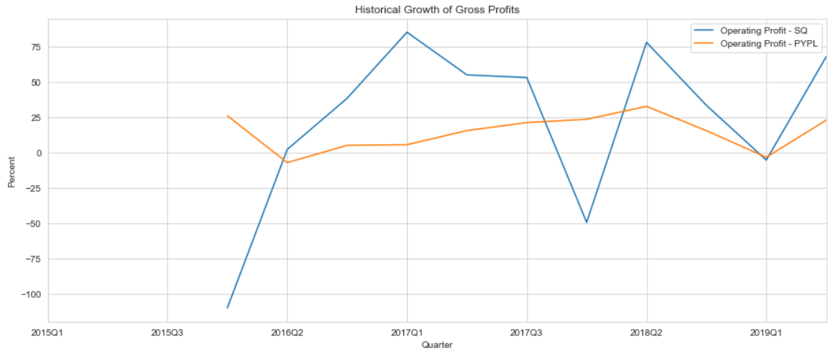

Analysing the growth trends yields a much better comparison. Two takeaways:

1. Square is a more volatile stock. Since it's relatively newer, the company has enjoyed surges and suffered dips corresponding with the decline in product popularity (ex: Caviar) and the introduction of new products (ex: CashApp)
2. PayPal's stock has posted generally stable, but positive returns. This is another indicator that its a market staple in the p2p payment industry and will likely maintain positive revenue growth